Pie chart:
Basic Pie charts Does not work on Columss and Rows
Below steps should be done to create Pie Chart
- Select pie in charts from
  - marks
  - show me panel
- Size = Measures
- Colour = Dimenstion
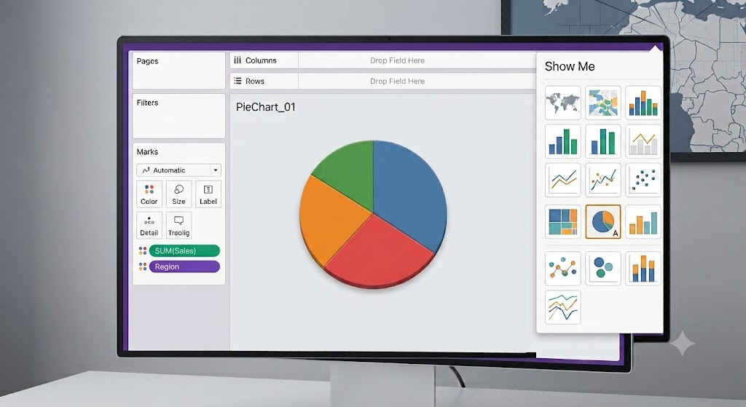

Waterfall chart
- 1st Create bar chart
- Sort it
- Inside marks select Gantt Bar
- Isert Measures[sales] inside size.

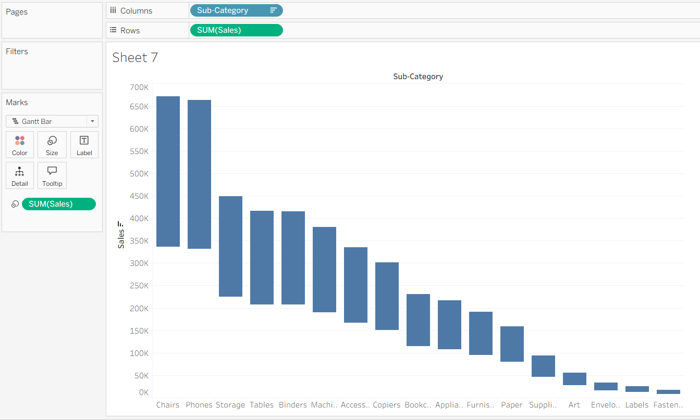

Funnel chart
- Inside row insert measure(sales,profit,marks)
- Dimenstion in colors(Category,segement,sub-category)
- Sort the chart
- Insert Measure isnside size.(sales,profit,marks)

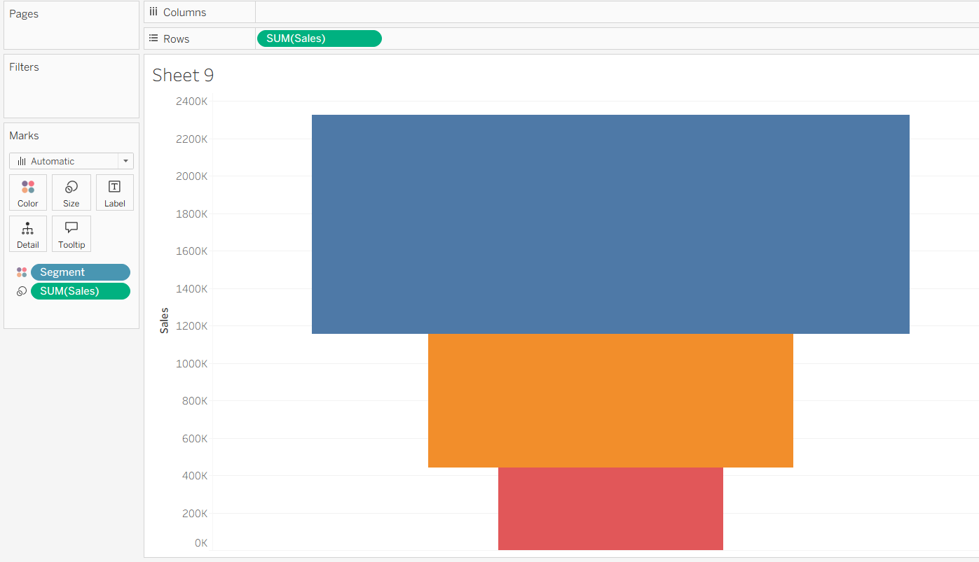

Dual axis chart:
- 1st create bar or line chart with two measure
- Then click on one measure and select dual axis chart
- From marks for one chart give circle and for other give bar.

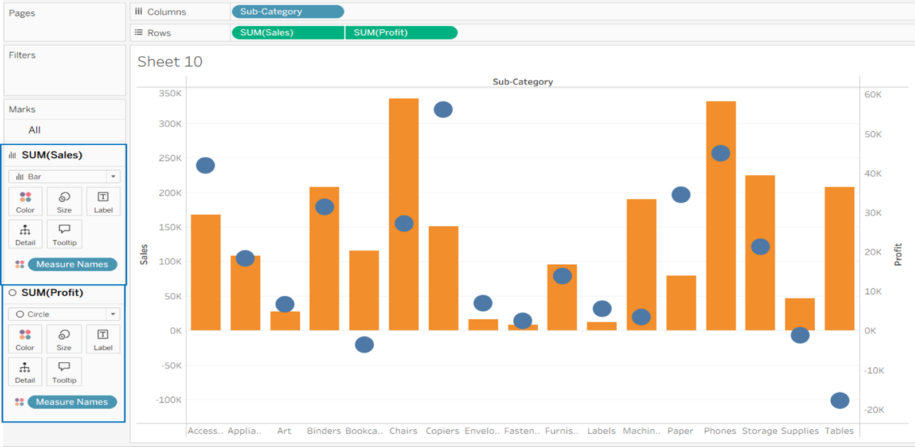

Scatter plot

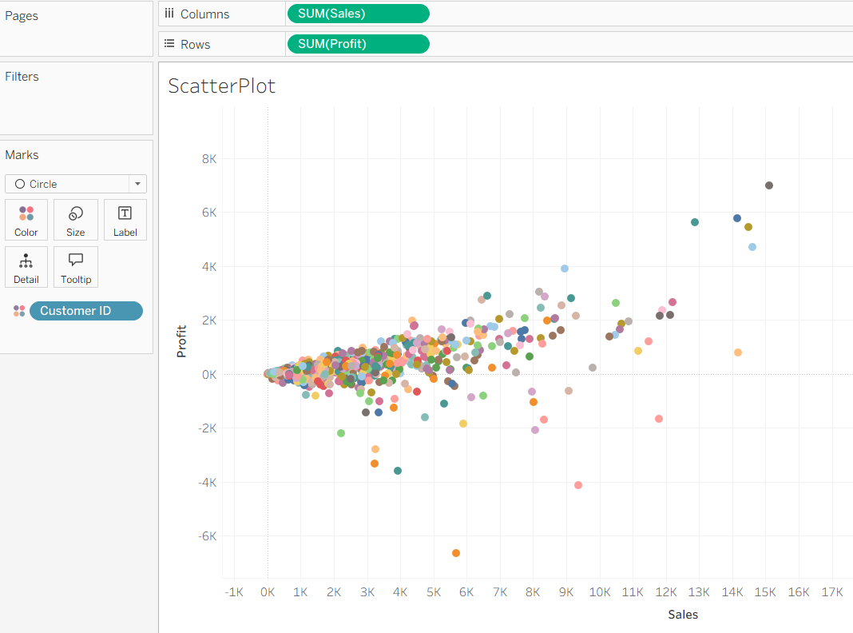

Colums: Category
Rows : Sales

Colums: Category , Sub-Category
Rows : Sales
Color subcategory
Label: sub-Category

Waterfall chart
1st create the bar chart
Then follow
Grantt bar
Colours: Dimension
Size: measure
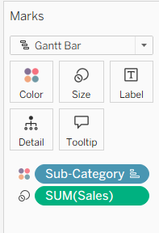

Funnel Chart
Columns: Blank
Row : Sales
